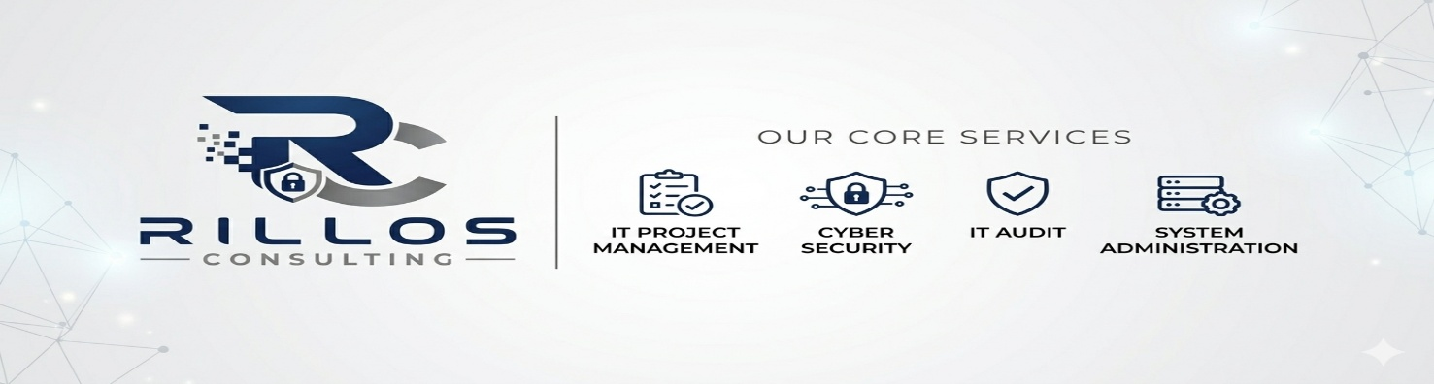

Below is a practical Information Technology (IT) Assessment & Audit Form designed for a small healthcare clinic, medical practice, dental office, behavioral health clinic, or similar healthcare organization. The form helps a new IT provider understand the organization's current technology environment, identify risks, assess HIPAA compliance readiness, and align technology services with business goals.

IT ASSESSMENT & AUDIT FORM
Healthcare Clinic Technology Evaluation
Clinic Information
Organization Name
Address
Primary Contact
Title
Phone Number
Email Address
Number of Providers
Number of Employees
Number of Locations
Date of Assessment
IT Assessor
SECTION 1: BUSINESS OBJECTIVES
Current Organizational Goals

Please rank each objective:

Goal Priority (High/Medium/Low)
Improve cybersecurity
HIPAA compliance
Reduce downtime
Improve staff productivity
Expand locations
Improve patient experience
Reduce IT costs
Improve telehealth services
Modernize systems
Improve disaster recovery
Additional Technology Goals
What technology challenges are you currently experiencing?
What would you like your IT environment to look like in 1-3 years?
Are there any upcoming projects or organizational changes?

□ New location

□ Additional providers

□ New EHR system

□ Telehealth expansion

□ Merger/Acquisition

□ Other: _______________________

SECTION 2: ORGANIZATION OVERVIEW
Staffing
Role Quantity
Physicians/Providers
Nurses
Administrative Staff
Billing Staff
Remote Workers
Contractors
Patient Volume
Item Quantity
Average Daily Patients
Monthly Patient Visits
Telehealth Visits Per Month
SECTION 3: NETWORK INFRASTRUCTURE
Internet Services Item Details
Internet Provider
Download Speed
Upload Speed
Backup Internet Connection Yes / No
Internet Reliability Issues Yes / No
Network Equipment
Equipment Manufacturer/Model Approximate Age
Firewall
Router
Switches
Wireless Access Points
Wireless Network

□ Guest Wi-Fi available

□ Staff Wi-Fi available

□ Separate patient network

□ WPA2/WPA3 security enabled

□ Unknown

Comments:

SECTION 4: COMPUTER SYSTEMS
Workstations
Type Quantity Average Age
Desktop Computers
Laptops
Tablets
Mobile Devices
Operating Systems
Operating System Quantity (How many users have seats/licenses)
Windows 11
Windows 10
MacOS
Other
Device Management

□ Centralized management

□ Automatic updates enabled

□ Endpoint security installed

□ Device inventory maintained

□ None of the above

SECTION 5: SERVERS & CLOUD SERVICES
Server Environment

□ Physical Server(s)

□ Virtual Server(s)

□ Cloud Hosted

□ No Local Servers

Current Systems
System Location
Electronic Health Record (EHR)
File Storage
Practice Management Software
Imaging System
Billing System
Backup System
Cloud Applications
Application Vendor
Microsoft 365
Google Workspace
Telehealth Platform
EHR
Other
SECTION 6: CYBERSECURITY REVIEW
Security Controls
Security Control Yes No
Multi-Factor Authentication (MFA) □ □
Antivirus/Endpoint Protection □ □
Firewall Installed □ □
Email Security Filtering □ □
Security Awareness Training □ □
Password Policy □ □
Encryption on Devices □ □
VPN for Remote Access □ □
Security Monitoring □ □
Security Incidents
Have you experienced a cyberattack or data breach in the last 3 years?

□ Yes

□ No

If yes, describe:

Have you experienced ransomware?

□ Yes

□ No

SECTION 7: HIPAA COMPLIANCE ASSESSMENT
Administrative Safeguards
Requirement Yes No Unknown
Annual Risk Assessment □ □ □
HIPAA Policies Documented □ □ □
Workforce Training Completed □ □ □
Incident Response Plan □ □ □
Technical Safeguards
Requirement Yes No Unknown
Audit Logging Enabled □ □ □
Unique User Accounts □ □ □
Access Controls Implemented □ □ □
Data Encryption □ □ □
Automatic Session Timeout □ □ □
Business Associate Agreements (BAAs)

□ Maintained for vendors

□ Not maintained

□ Unknown

SECTION 8: BACKUP & DISASTER RECOVERY
Backup Review
Item Yes No
Daily Backups Performed □ □
Offsite Backup Storage □ □
Backup Testing Conducted □ □
Disaster Recovery Plan Exists □ □
Written Recovery Procedures □ □
Recovery Objectives
Objective Target
Maximum Acceptable Downtime
Maximum Acceptable Data Loss
SECTION 9: TELEPHONE & COMMUNICATIONS
Phone System

□ Traditional PBX

□ VoIP

□ Cloud-Based

Provider:

Communication Tools

□ Microsoft Teams

□ Zoom

□ Secure Messaging

□ Telehealth Platform

□ Other

SECTION 10: IT SUPPORT & VENDOR MANAGEMENT
Current IT Support
Item Details
Current IT Provider
Contract Expiration
Help Desk Available Yes / No
Onsite Support Available Yes / No
Response Time Expectations
Vendor Inventory
Vendor Service
EHR Vendor
Billing Vendor
Internet Provider
Phone Provider
Other Vendors
SECTION 11: RISK ASSESSMENT SUMMARY (IT PROVIDER COMPLETES)
Risk Area Low Medium High
Cybersecurity □ □ □
HIPAA Compliance □ □ □
Backups □ □ □
Infrastructure □ □ □
Hardware Lifecycle □ □ □
User Training □ □ □
Top Findings
SECTION 12: RECOMMENDED ROADMAP (IT PROVIDER COMPLETES)
Immediate Priorities (0–90 Days)
Short-Term Improvements (3–12 Months)
Long-Term Strategy (1–3 Years)
Executive Summary

□ Basic

□ Developing

□ Managed

□ Advanced

Estimated Technology Budget Considerations
Assessor E-Signature:
Clinic Representative Signature:
Date:

